

**CAPSTONE PROJECT 1**

**ROOMY SYSTEM MANAGEMENT**

**USER INTERFACE DESIGN DOCUMENT**

Version 1.1

Date: Sep 1, 2018

**MENTOR** **: MSc, Phan Van Son**

**PROJECT TEAM** : **Bule team**

**TEAM’S MEMBER** : Huynh Quoc Nhat

Le Hoang Quoc

Ho Trung Anh

Huynh Vu Ha Lan

Huynh Thi Thanh Van

**INTERNATIONAL SCHOOL**

**Project Information**

|  |  |  |  |  |  |
| --- | --- | --- | --- | --- | --- |
| **Project acronym** | RSM | | | | |
| **Project Tittle** | Roomy System Management | | | | |
| **Start Date** | Aug 15, 2017 | | **End Date** | | Dec 5, 2017 |
| **Lead Institution** | International School, Duy Tan University | | | | |
| **Project Mentor & contact details** | MSc.Phan Van Son  Email: [sonpvs@duytan.edu.vn](mailto:sonpvs@duytan.edu.vn)  Tel: 0905151655 | | | | |
| **Scrum Master & contact details** | Huynh Vu Ha Lan  Email: [huynhvuhalan.97@gmail.com](mailto:huynhvuhalan.97@gmail.com)  Tel: 01675373265 | | | | |
| **Team members** | **Name** | **Email** | | **Tel** | |
| Huynh Quoc Nhat | [huynhquocnhat97@gmail.com](mailto:huynhquocnhat97@gmail.com) | | 0905740256 | |
| Le Hoang Quoc | [quocle28292@gmail.com](mailto:quocle28292@gmail.com) | | 01657708105 | |
| Ho Trung Anh | [hotrunganhht1912@gmail.com](mailto:hotrunganhht1912@gmail.com) | | 09055258534 | |
|  | Huynh Thi Thanh Van | [thanhvandb97@gmail.com](mailto:thanhvandb97@gmail.com) | | 01229444661 | |

**User Interface Design Document**

|  |  |  |  |
| --- | --- | --- | --- |
| **Document Title** | **User Interface Design** |  |  |
| **Reporting Period** | Sep 1 , 2018 |  |  |
| **Author(s) &**  **project** | Huynh Vu Ha Lan,  Scrum Master | |  |
| **Team Information** | **Name** | **Role** |  |
| Huynh Quoc Nhat | Member |  |
| Le Hoang Quoc | Member |  |
| Ho Trung Anh | Member |  |
|  | Huynh Thi ThanhVan | Member |  |
| **Date** | Sep 1, 2018 | **Filename** | UserInterfaceDesign_V1.1.docx |
| **Access** | Project and CMU Program | |  |

**REVISION HISTORY**

|  |  |  |  |
| --- | --- | --- | --- |
| **Version** | **Person** | **Date** | **Description** |
| V1.0 | Team | Sep 1, 2018 | Draft for Document |
| V1.1 | Huynh Thi Thanh Van | Sep 9, 2017 | Update Interface |

**Document Approvals**

The following signatures are required for approval of this document.

|  |  |  |  |
| --- | --- | --- | --- |
| **Mentor & Customer** | MSc.Phan Van Son | **Signature:** |  |
| **Date:** |  |
| **Scrum Master** | Huynh Vu Ha Lan | **Signature:** |  |
| **Date:** |  |

Contents

1. Overview 6

1.1. Purpose 6

1.2. Related Documents 6

2. Interface Design 7

2.1 Home page 7

2.2 Login 8

2.3 Register 8

2.4 View information 9

2.5 Update information 10

2.6 Search about accommodation 10

2.7 Manage zone 11

2.8 Add zone 11

2.9 Update zone 12

2.10 Delete zone 13

2.11 Add room 14

2.12 Update room 15

2.13 Delete room 17

2.14 View detail accommodation 17

2.15 Report for admin accommodation 19

2.16 Booking room 19

2.17 Accept booking room 19

2.18 Terminate the rental 20

2.19 History of booking 21

2.20 Login for admin 22

2.21 Home page of admin 22

2.22 Create new admin 23

2.23 View list zone 23

2.24 Zone statistic 24

2.25 View list account 25

2.26 View report 26

1. **Overview**
   1. **Purpose**

• This document helps to better understand the interface of the Roomy System Management website, detailed specification components and function of the system.

• With this document, the development team can understand detail the structure and composition to create a consistent and complete system.

* 1. **Related Documents**

• ProductBacklog_v1.1

1. **Interface Design**
   1. **Home page**

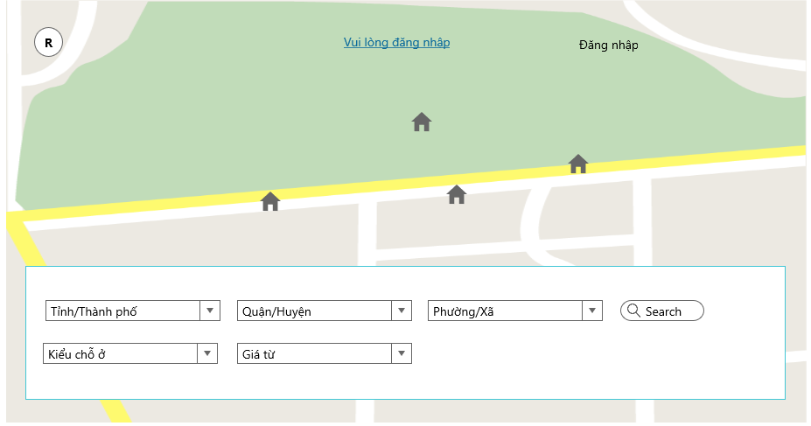

* 1. **Login**

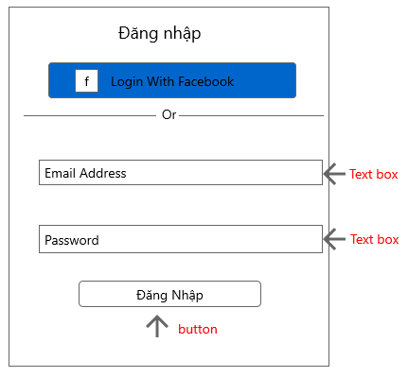

* 1. **Register**

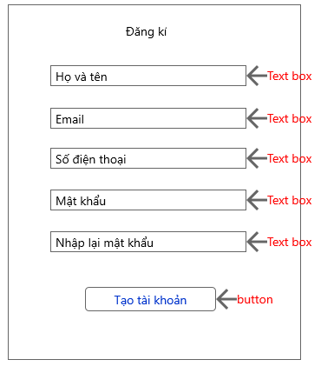

* 1. **View information**

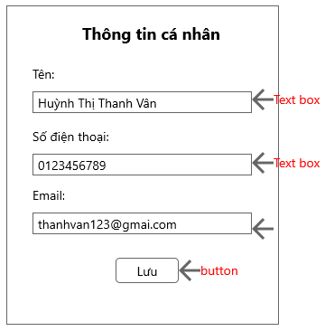

* 1. **Update Information**



* 1. **Searching information about accommodation**

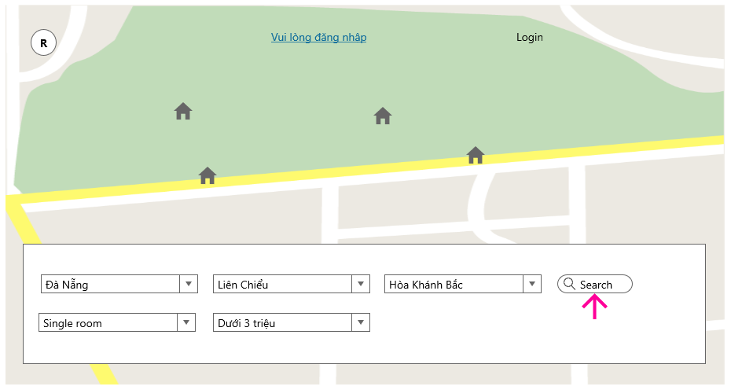

* 1. **Manage zone(Landlord)**

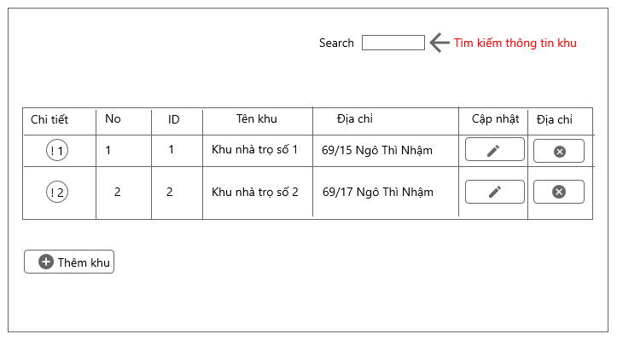

* 1. **Add Zone**

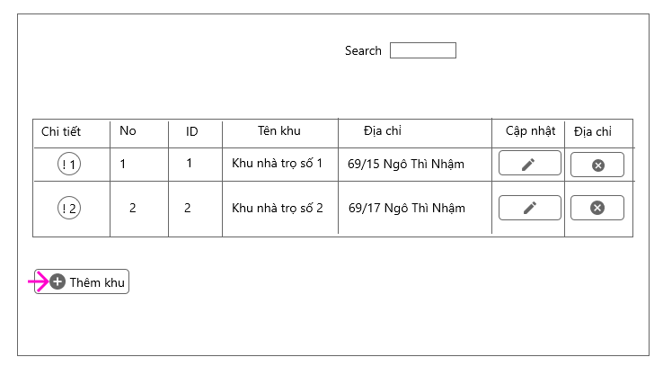

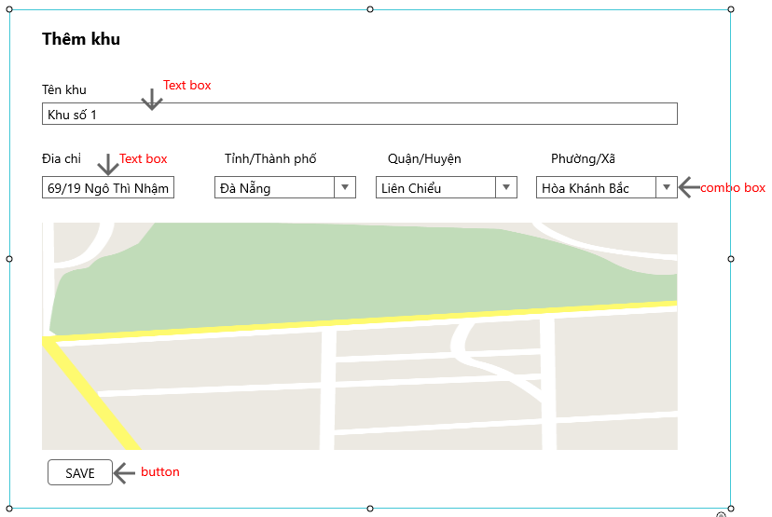

* 1. **Update Zone**

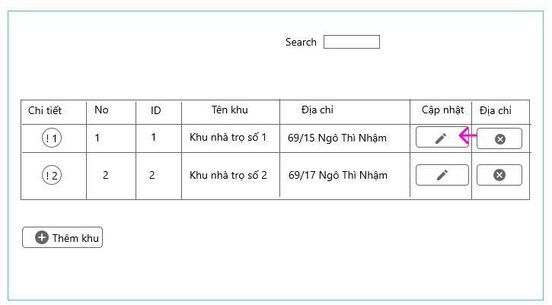

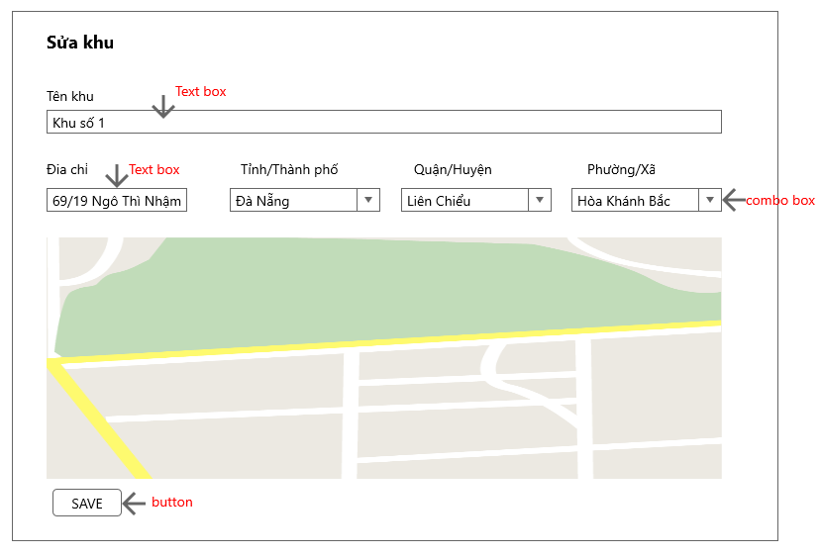

* 1. **Delete Zone**

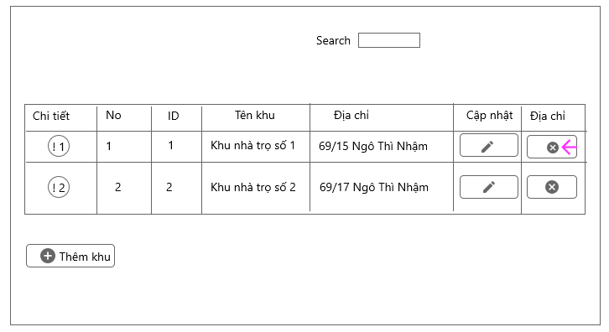

* 1. **Add room**

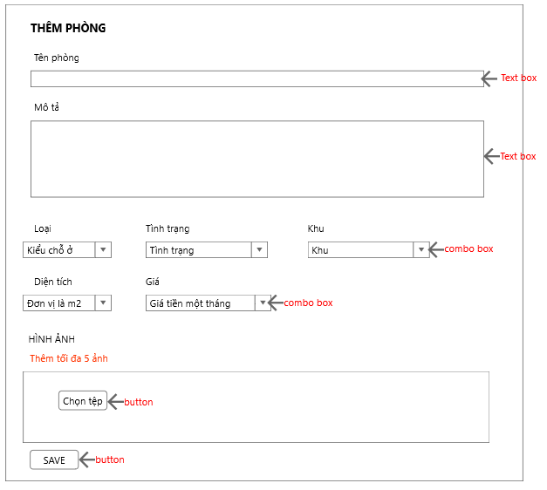

* 1. **Update room**

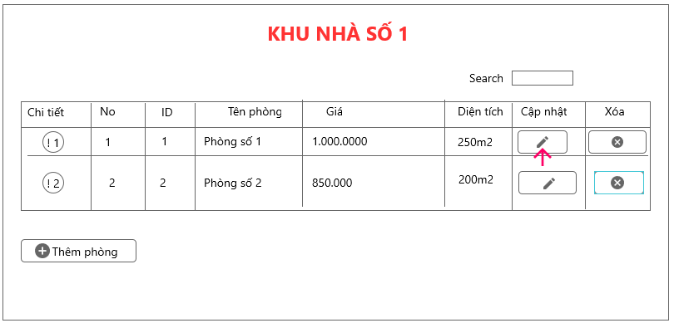

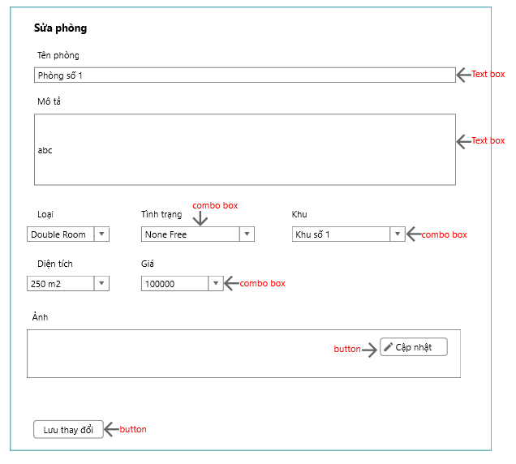

* 1. **Delete room**

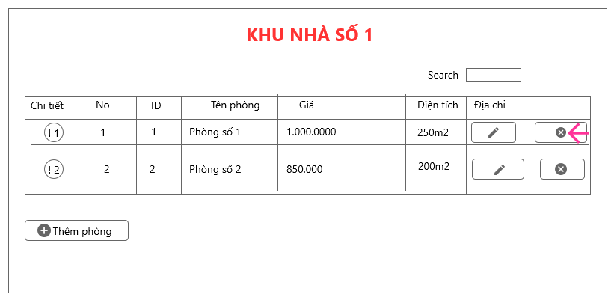

* 1. **View detail accommodation**

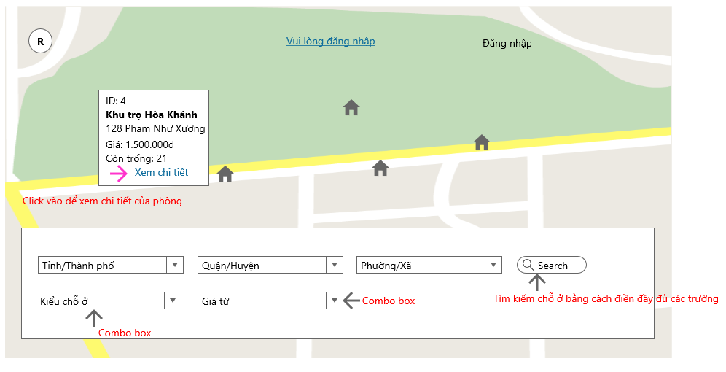

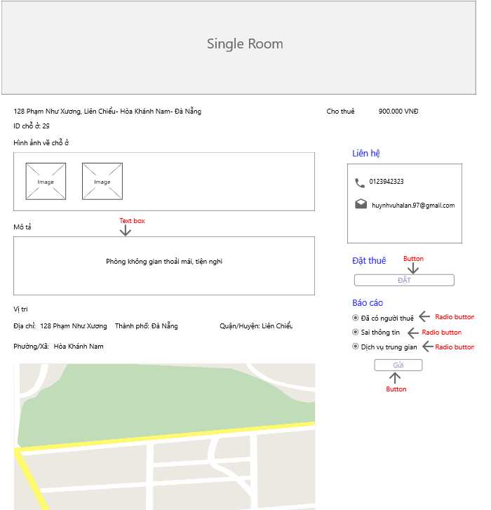

* 1. **Report for admin about accommodation**

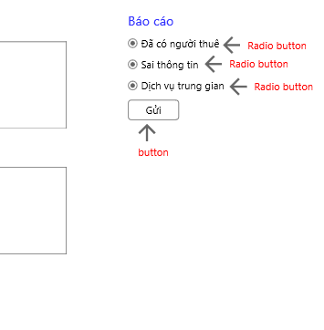

* 1. **Booking room**

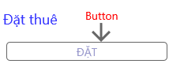

* 1. **Accept booking room**

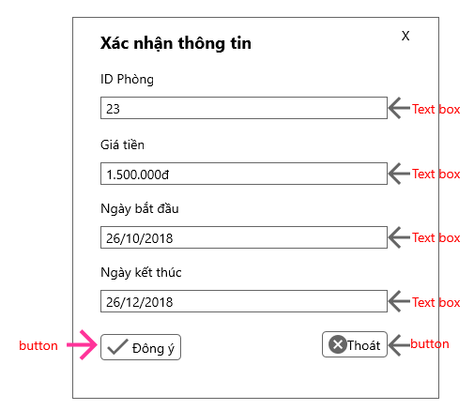

* 1. **Terminate the rental**

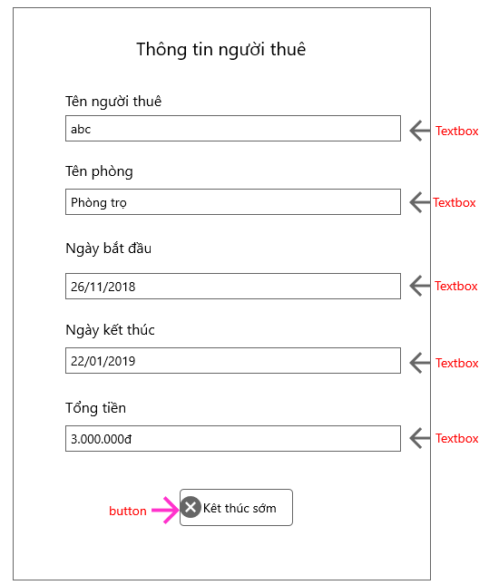

* 1. **History of booking**

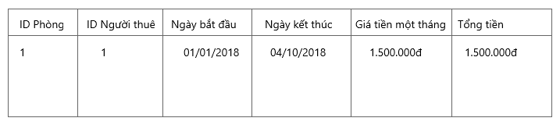

* 1. **Login for admin**

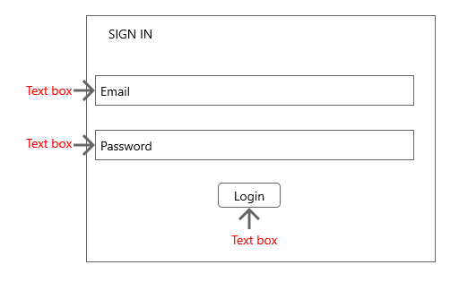

* 1. **Home page for admin**

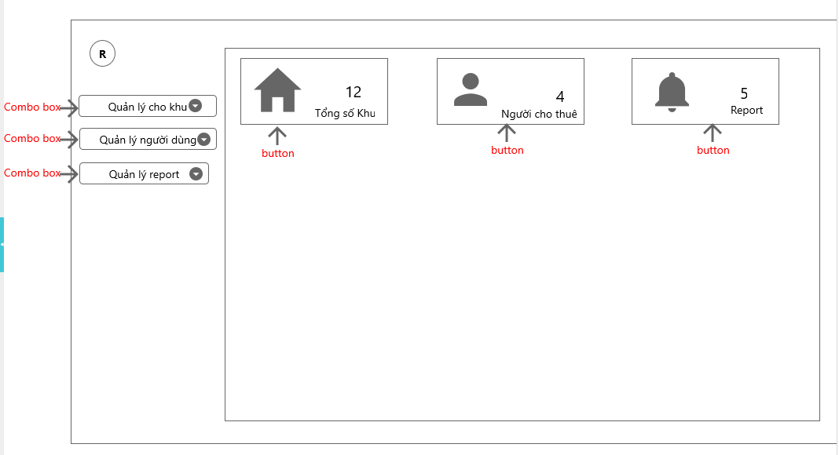

* 1. **Create new admin**

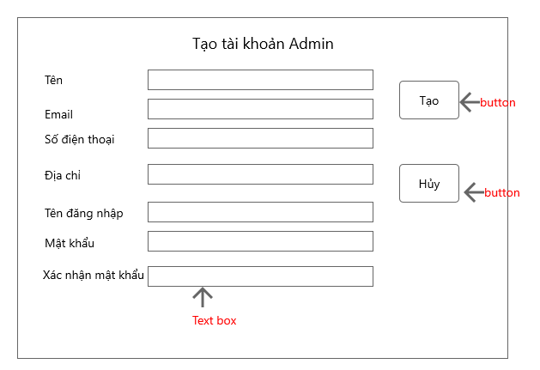

* 1. **View list zone**

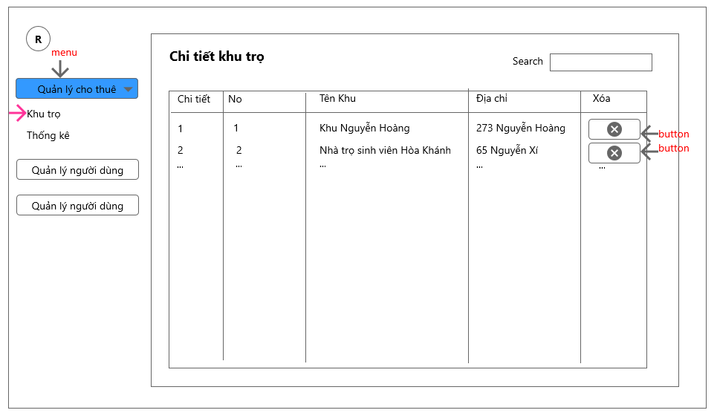

* 1. **Zone statistic**

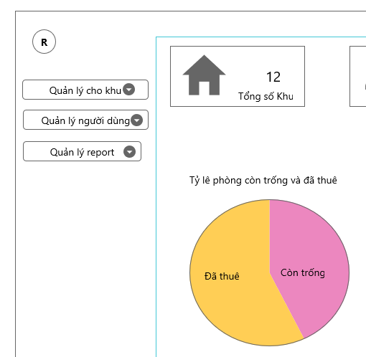

* 1. **View list account**

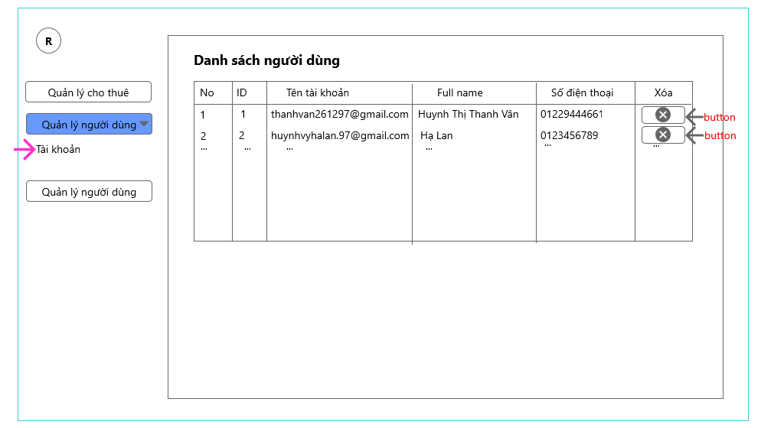

* 1. **View report**

